Finance AI Platform - Current-State Architecture
Detailed architecture documentation through Phase 3H-F-F | Pre-3I baseline
Purpose: preserve a clear technical record of the product architecture, flows, evidence model, safety boundaries, and capabilities implemented before the multi-agent coordinator phase.
Architecture snapshot: This document captures the implemented single-agent architecture through document-aware RAG, LangGraph tool orchestration, CSV/chart analysis, financial fact extraction, public web fallback, provenance UI, caching, rate controls, and end-to-end hardening. 3I multi-agent coordination, 3J compliance dashboard, and 3K event automation are intentionally shown only as future boundaries.

Figure 1. Capability evolution from document-aware chat to the hardened 3H web-grounded architecture.

1. Executive architecture summary
The product currently uses a controlled single-agent orchestration model. The Next.js frontend exposes document search, chat, data-analysis and provenance experiences. A FastAPI service runs the LangGraph workflow, plans an allow-listed set of finance tools, retrieves document evidence, extracts structured financial facts, optionally performs web research when local evidence is insufficient and explicit fallback permission is enabled, validates grounding, and returns a browser-safe public response.
- Local documents are the primary evidence path. Public web research is a fallback, not the default.
- Document evidence and web evidence remain visibly distinct: local sources use Source 1..N; web citations use Web Source 2001+.
- Approved memory is used only for style/workflow preferences and is not treated as factual financial evidence.
- Quantitative finance requests can use deterministic or structured fact paths rather than relying only on free-form LLM generation.
- Web access is guarded by request limits, explicit user permission, URL/SSRF protections, provider-failure containment, citation integrity checks, and search/fetch caches.
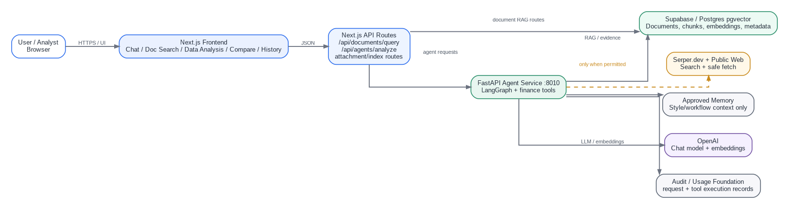
Figure 2. Current system context and external dependencies.

2. Application and service boundaries
The implementation is deliberately split into client experience, Next.js API routes, and the Python agent runtime. This separation keeps UI concerns, request-contract translation, and agent execution independently testable.
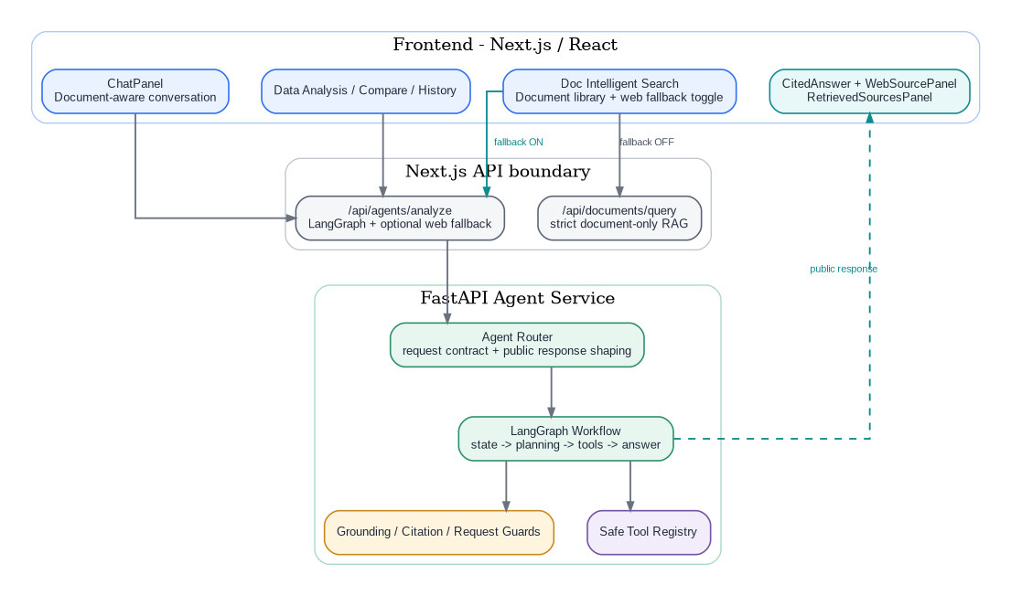
Figure 3. Layered application architecture: frontend, API boundary, and FastAPI agent runtime.
Component | Current implementation
Frontend | Next.js / React. Main user experiences include Chat, Doc Intelligent Search, Data Analysis, Compare and History. Provenance components include CitedAnswer, WebSourcePanel and collapsible retrieved-source panels.
Strict RAG API | /api/documents/query. Used when web fallback is disabled; retrieves selected document chunks and returns a grounded answer or refusal.
Agent API | /api/agents/analyze. Used for LangGraph execution and the web-enabled path. Carries use_documents, document_ids, top_k, allow_web_fallback and trusted_web_domains into the backend.
FastAPI agent service | Runs on port 8010 in the current development setup. Owns graph state, planning, tool execution, answer generation, grounding, public response shaping and web-fallback orchestration.

3. Single-agent LangGraph orchestration
Before 3I, the product is intentionally a single coordinating graph with multiple bounded tools. The planner decides which tools are needed; tools do not recursively create other agents. This provides a stable baseline for later multi-agent orchestration.
Figure 4. Current LangGraph request lifecycle.
Important boundary before 3I: The planner selects tools, not autonomous specialist agents. Evidence is merged into one graph state and one final answer path. 3I will wrap proven tool domains behind specialist agent contracts without discarding these safety controls.

4. Document ingestion and RAG architecture
Uploaded finance documents are converted into searchable chunks, embedded, and stored with identifiers and metadata. Queries use the same embedding space to retrieve top-K evidence. The returned chunks include document identifiers, chunk identifiers, scores and snippets so the answer can be traced back to the uploaded source.
Figure 5. Document ingestion, embedding and retrieval pipeline.
Component | Current implementation
Embedding model | text-embedding-3-small is used in the current RAG path.
Vector storage | Supabase/Postgres pgvector is the main indexed retrieval foundation. Local development support/fallback storage exists where configured.
Retrieval contract | Selected document IDs + question + top-K produce ranked chunks with score, file name, chunk index and snippet.
Grounding behavior | The document-only route instructs the answer model to use retrieved evidence only. Missing requested periods/metrics cause a refusal rather than invention.

5. Document-only request flow
When the Public Web Fallback toggle is off, Doc Intelligent Search remains a strict local-RAG product path. No Serper request or public-web fetch is permitted.
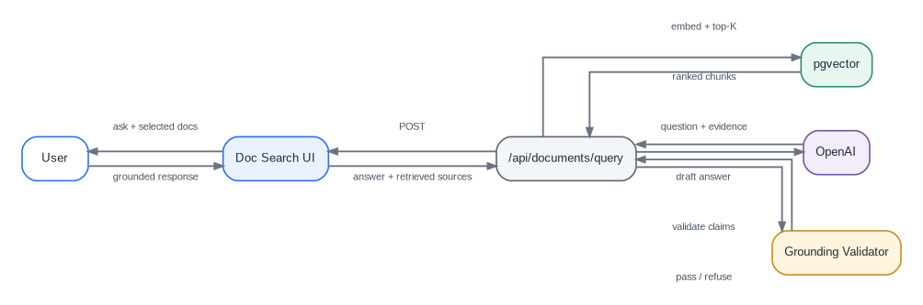
Figure 6. End-to-end document-only request sequence.
- The user selects one or more indexed documents and submits a question.
- The route retrieves relevant chunks from the selected document scope.
- The model receives only the selected question and retrieved evidence context.
- The grounding validator can replace an unsupported draft with a refusal and explanation.
- The UI shows the answer beside/with collapsible retrieved source evidence.

6. Safe tool registry and capabilities
The graph does not execute arbitrary tool names. A structured ToolPlan and allow-listed registry constrain what can run. This is the core safety boundary that 3I should preserve when tools become specialist-agent capabilities.
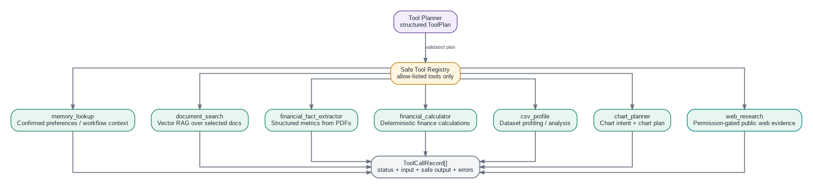
Figure 7. Safe tool registry and current finance capabilities.
Component | Current implementation
memory_lookup | Reads confirmed style/workflow preferences. It is not valid evidence for financial facts.
document_search | Runs vector search over explicitly selected document IDs.
financial_fact_extractor | Extracts structured finance facts from local documents when quantitative intent is detected and evidence supports the requested metric/period.
financial_calculator | Provides deterministic calculations rather than delegating arithmetic to free-form generation.
csv_profile | Profiles and supports analysis of uploaded tabular data.
chart_planner | Produces chart intent and visualization planning for data-analysis flows.
web_research | Runs only when the local-evidence gap detector signals need and allow_web_fallback is true.

7. Structured financial fact extraction
Quantitative finance questions are treated differently from ordinary narrative Q&A. The system first checks whether retrieved local evidence explicitly supports the requested metric and period. If it does, a structured extractor can emit normalized facts; if not, the missing fact becomes a reason for web fallback when permission exists.
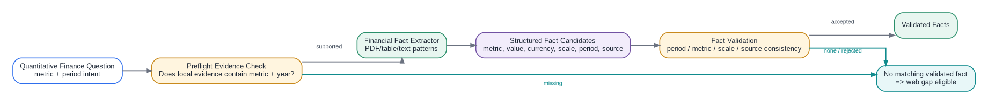
Figure 8. Local structured financial fact extraction and validation path.
- Fact records carry metric label, raw value, normalized numeric value, scale, currency/unit, period, source and validation information.
- The system does not promote every extracted number into the answer. Validation protects against period, metric and scale mismatch.
- A validated fact can take a deterministic answer path, reducing the chance that the LLM ignores or contradicts a verified numeric result.

8. CSV analysis and chart planning
The platform also supports data-centric questions that are not document RAG. CSV profiling produces schema and summary information; analysis can then use the structured profile, and chart planning can translate the request into an appropriate visualization specification.
Figure 9. CSV analysis and chart planning flow.

9. 3H public web fallback architecture
3H adds current/public evidence only when local document evidence is incomplete and the user has enabled fallback. It is designed as a controlled evidence-acquisition pipeline rather than unrestricted browsing.
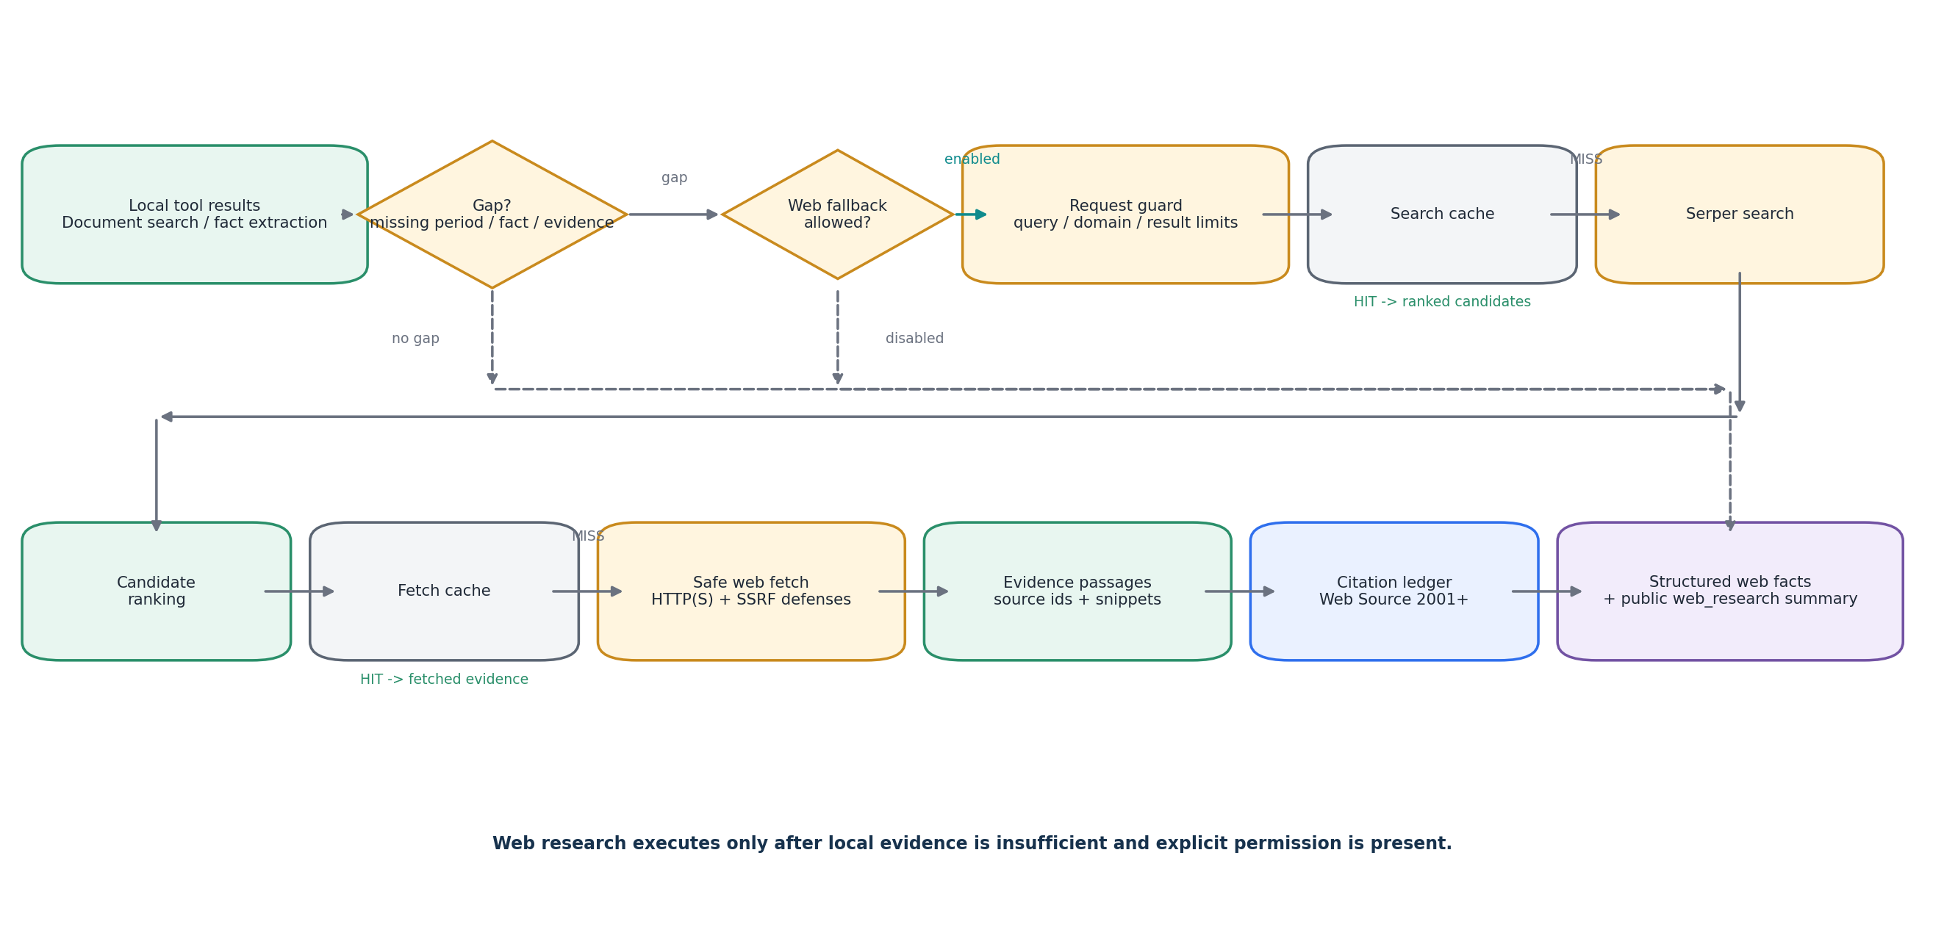
Figure 10. Web fallback from local evidence gap to public browser-safe citations.
Component | Current implementation
Gap detection | Checks whether local tools produced evidence adequate for the question, including requested year/metric support for quantitative finance questions.
Permission gate | allow_web_fallback must be true. With the toggle off, the provider is never called even if the gap detector says web evidence would help.
Request guard | Caps query length, result count and trusted-domain count and normalizes trusted domains.
Search provider | Serper.dev performs public search. Search results are ranked and filtered before fetch.
Safe fetch | Only safe public HTTP(S) destinations are fetched; malformed/private/loopback/credential-bearing/unsafe-port URLs are blocked.
Citation ledger | Fetched evidence is persisted/represented as citation-ready Web Source numbers beginning at 2001.
Structured web facts | Quantitative intent can trigger web financial fact extraction and validation independently of local document extraction.

10. Evidence, citations, grounding and provenance
The product keeps the answer separate from the evidence objects that support it. This is essential for finance: local document citations, web citations and validated facts are carried through the response as distinct structured records.
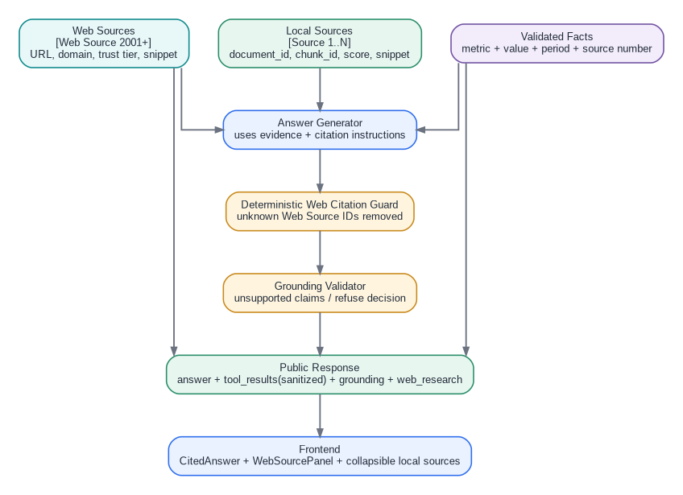
Figure 11. Evidence provenance from source records to browser rendering.
- Local evidence uses Source 1..N and retains document/chunk metadata.
- Web evidence uses Web Source 2001+ and carries URL, domain, trust tier, content type, retrieval time and concise snippet.
- CitedAnswer only makes a Web Source reference clickable if the matching citation exists in the public response.
- WebSourcePanel presents concise web summary/source cards; validated fact cards appear only when validated_facts is non-empty.
- Retrieved document sources can be collapsed and are secondary when web fallback was used, keeping the UI concise and making provenance hierarchy clear.

11. 3H-F-F hardening and failure behavior
The final 3H hardening phase verifies that the web path remains bounded under malformed input, provider outages, repeated queries and hallucinated citation references.
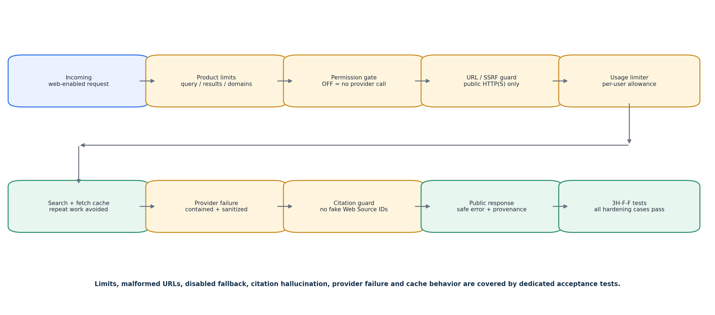
Figure 12. Web safety, reliability and cost-control layers verified by 3H-F-F tests.
Component | Current implementation
Product limits | Query length, trusted-domain count and maximum results are constrained.
Malformed URL defense | file:, javascript:, localhost, 127.0.0.1, credential-bearing URLs, unsafe ports and missing hosts are blocked.
Disabled fallback | Web provider is not called when allow_web_fallback is false.
Citation guard | Hallucinated [Web Source N] identifiers that do not exist in the public citation list are replaced with a non-linkable unavailable marker.
Provider failure | Internal diagnostic details stay server-side while the public response receives a generic safe failure reason.
Caching | First identical request produces search/fetch cache misses; repeated request produces hits and does not consume another search allowance.

Verified 3H-F-F acceptance result: Limits, malformed URL blocking, disabled-fallback behavior, citation-hallucination protection, provider-failure containment, and search/fetch cache behavior all passed the dedicated backend hardening test suite.

12. Data stores and trust boundaries
The architecture distinguishes untrusted client input, trusted application code, persistent RAG stores, external providers and untrusted public-web content. Safe-fetch and public-response sanitization are boundary controls, not optional helper functions.
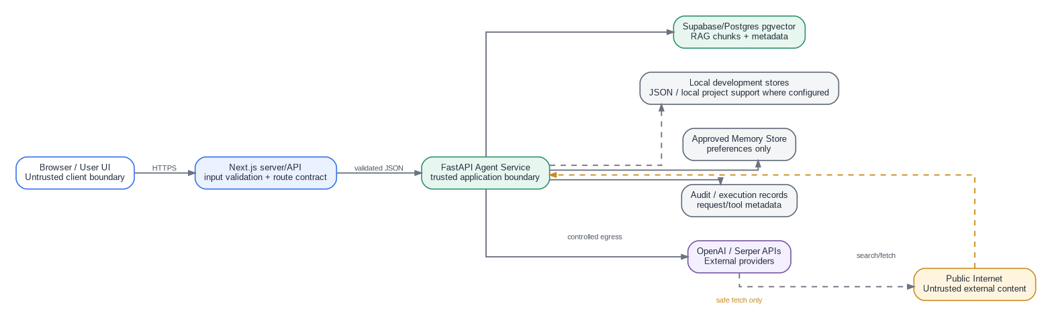
Figure 13. Data stores, provider integrations and trust boundaries.
Component | Current implementation
Browser | Untrusted client boundary. UI state such as web-fallback permission is sent through typed request contracts; it is not trusted until server validation.
Next.js server | Translates product-facing request shapes into strict RAG or agent-service contracts.
FastAPI service | Trusted orchestration runtime that enforces graph state, tool registry, guards, public response sanitization and evidence handling.
Supabase/Postgres pgvector | Persistent vector evidence and metadata used by document RAG.
External APIs | OpenAI and Serper are external provider dependencies. Failures are contained and do not expose raw provider diagnostics publicly.
Public web | Always treated as untrusted content. URLs and fetched content pass through request/fetch controls before becoming evidence.

13. Current implementation inventory
Area | Implemented baseline before 3I
Frontend | Next.js/React UI with document search, chat, data analysis, compare/history areas, web fallback toggle, cited answer rendering and collapsible provenance/source cards.
Backend | FastAPI agent-service with LangGraph state and nodes for planning, tool execution, answer generation and grounding.
RAG | Document indexing, OpenAI embeddings, Supabase pgvector retrieval and source-scoped top-K search.
Finance tooling | Financial calculations, structured PDF financial fact extraction, CSV profiling and chart planning.
Memory | Approved memory lookup for preferences/workflow context only.
Web research | Serper search, safe fetch, evidence passages, citation ledger, structured web fact extraction, validation and product summary.
Hardening | Limits, SSRF/malformed URL defense, explicit fallback permission, provider failure isolation, citation integrity, cache behavior and public error sanitization.
Audit foundation | Request/tool execution metadata exists as a foundation; a production compliance metrics/audit dashboard is intentionally deferred to 3J.

14. What is deliberately not part of this baseline
The following are next-phase product capabilities and should not be confused with the current 3H architecture:
- 3I Multi-agent coordinator: typed specialist agents, task DAG, parallel execution, evidence reviewer and multi-agent budgets.
- 3J Compliance metrics and audit dashboard: unified audit event schema, governance checks, risk scoring, trace explorer and operational/compliance dashboards.
- 3K Event-driven automation: event schemas, durable queues, workflow engine, scheduling, webhooks, idempotency, retries/DLQ and human approvals.
Recommended architectural transition: Treat this document as the stable pre-3I baseline. New 3I agent wrappers should reuse document search, financial fact extraction, web research, calculation, CSV and chart capabilities behind typed agent contracts rather than reimplementing them.

15. Documentation maintenance checklist
- Update this architecture snapshot whenever API request/response contracts change.
- Maintain a versioned list of LangGraph nodes, tools and safety guards.
- Keep sequence diagrams aligned with frontend routing behavior, especially strict document-only versus agent/web-enabled paths.
- Record any new persistent data stores, external providers or network egress paths.
- Add every new failure/retry/cost-control mechanism to the hardening diagram and test matrix.
- Create a new architecture version at the start and completion of 3I, 3J and 3K rather than overwriting this pre-3I baseline.

